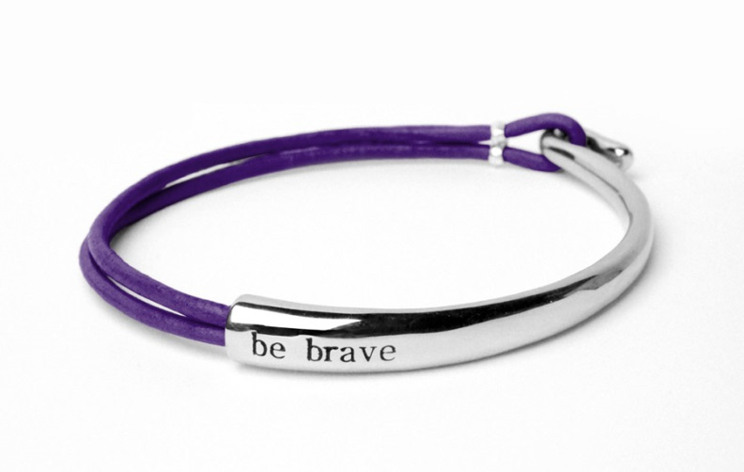

This marvelous bracelet cast from fine quality Brass and beads gives it an ethnic appeal. Traditionally designed and handcrafted to display a fine shine. .....

Product: BRACELET

Price:1,250.00 PKR

CONTACT US: Address: Aptech Metro StarGate Karachi

Phone.no: 03142191402

Email: feedback@aptech-educationcom.pk